## HP Elite Desktop - Unable to Power On

Normally we would contact HP support for this problem, but they have talked us through a relatively easy sequence that will likely fix the problem.

Most systems that have a RAM or disk problem might fail to boot, but they do light up the screen and try to POST. The HP's do not. So here is the sequence

1. Verify that
   1. The power cable is plugged in and good (try another known good cable?)
   2. There is power at the outlet and/or power strip
2. If 1a & 1b are good, unplug the power cable, and open the computer's case
3. Gently remove the RAM (note orientation), remove any dust, and carefully reseat the RAM.
4. Plug the power cable back in and try powering up the computer. If it works, you are done - just close the case up and put things back together.
5. If you are at this step, the computer still isn't powering up. So the next step is to
   1. Unplug the power cable
   2. Press the little yellow button near the CMOS battery and the CPU, holding it down for about 30 seconds (see figure 1)
   3. Plug the power cable into the computer, and try powering up again. If it works, you are done, and put the computer case cover back on, monitor back in place, etc.
   4. The little yellow reset button process can alter the BIOS settings. On power-up, get into the BIOS (press F10 during power-up, you will need the BIOS password)
   5. Do the same on the computer next to the one you are working on - you want to compare BIOS settings (yes, it is tedious), and correct any settings on the just-repaired computer that are different from the "good" computer's BIOS settings. Save the changes, reboot, and verify all works again. You are done.
6. If you reach this point, the next step is to disconnect the power cable, open the case, and disconnect the power cable to the SATA disk drive (see figure 2). You may hear a capacitor discharge - don't worry. Wait about 30 seconds, then reconnect the cable to the disk drive. Reconnect the computer's power cable, and try powering up. If it powers up, continue at step 4.d & 4.3 above. However, if it does not power up, contact one of the IST system admins. They will contact HP (if the computer is still under warranty) and have it repaired by HP.

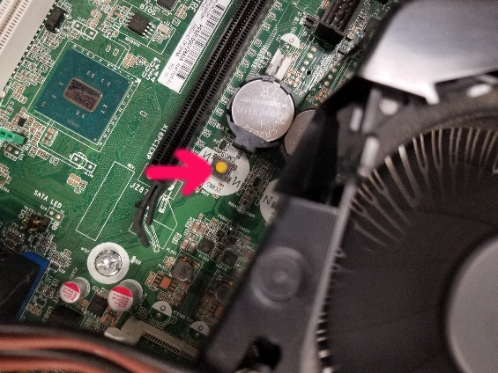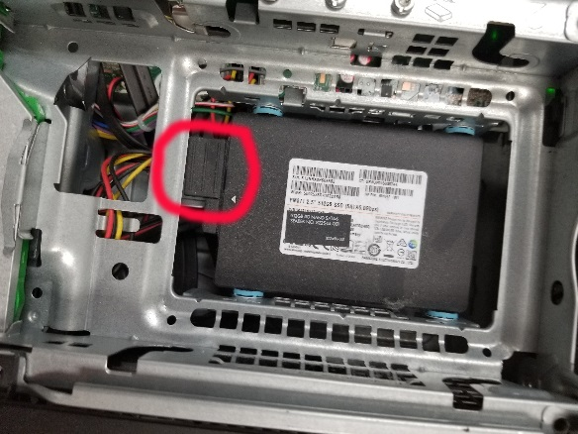Figure 1 Figure 2